  - Introduction
Ethanol or ethyl alcohol (C₂H₅OH) has gained its importance as important chemical feed stock for various industrial solvent and ranks second only to water (Rose, 1967). It is an important solvent for the synthesis of pharmaceuticals, detergents, adhesives, plastics, plasticizers and a host of other chemicals. Ethanol is also used as an important intermediate for the production of a number of chemicals such as acetaldehyde, acetone, chloroform etc, and figure 1 shows most of them (Sherman and Kavasmaneck, 1978; Pturau, 1982). Ethanol is the active constituent of all intoxicating liquors. Alcoholic beverages such as beer, whisky, rum, gin etc., also have a good demand in the market worldwide. Smith and Ferdinand (1940), estimated that mans use of beverages alcohol has been going on for some three hundred centuries.
In the recent scenario, it is emerging as a fuel option for automobiles as gasohol. Gasohol is produced by dissolving 5 to 15% absolute water free alcohol in gasoline (Sybil, 1997). The continuously increasing oil price, the depleting petroleum resources and the environmental concerns, diverts the attention of the world towards a safe, cheaper and a renewable energy source. The quadrupling of the selling price of crude petroleum by the Organization of Petroleum Exporting Countries (OPEC) in 1973, has profound impact on fermentation processes for producing ethanol (Paul Dwight and Percy, 1980). Ethanol can be produced from biomass and hence it is called a renewable fuel. The fuel use of fermentative ethanol is steadily increasing in Brazil (Kislin, 1980), US and West Germany (Muensterer, 1976). Scheller William, 1977, reported that fermentative ethanol production by fermentation from grains is cheaper to that produced from ethylene when alcohol is commercially produced. In the case of synthetic ethanol production from ethylene, an energy equivalent of approximately two liters of ethanol is consumed for every liter produced (Scheller and Mohr, 1977). It has also been claimed as an economic additive to unleaded automotive fuel (Scheller, 1974; Scheller, 1975).
The usage of ethanol blends with gasoline started in brazil as early as 1931. By 1978, the fuel alcohol content has increased from 5% to 12 vol% (Yand and Trindade, 1979). Engines operating on gasohol start easier at cold temperatures, which are advantageous in countries with cold climates (Franklinger, 1980). An 85 vol% ethanol and 15vol% petrol blends are likely to be used in US in specially designed vehicles in the years to come.

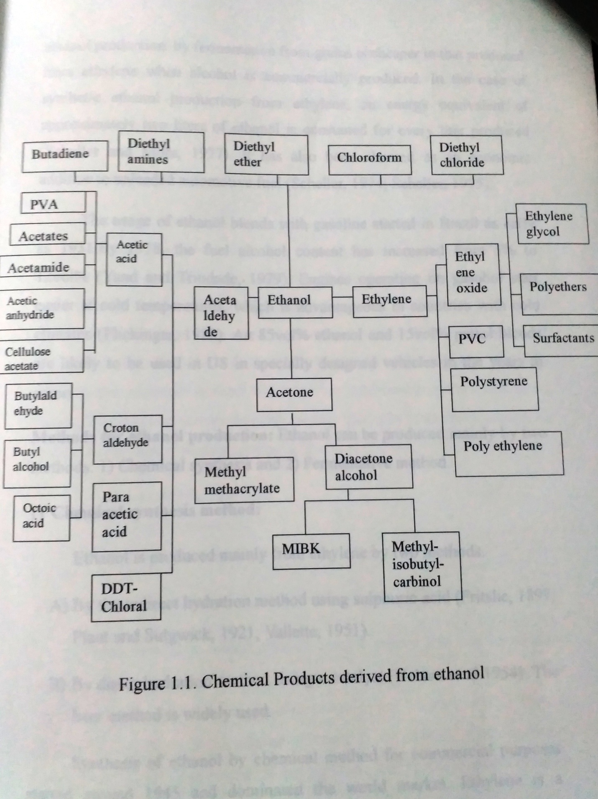
Methods of ethanol production: Ethanol can be produced mainly by two methods. 1) chemical synthesis and 2) fermentative method.
1) Chemical synthesis method:
Ethanol is produced mainly from ethylene by two methods
- By the indirect hydration method using Sulphuric acid (Fritshe, 1897; Plant and Sidgwick, 1921;Vallette, 1951).
- By direct hydration method using a catalyst (Nelson et al., 1954). The later method is widely used.
Synthesis of ethanol by chemical method for commercial purposes started around 1945 and dominated the world market. Ethylene is a byproduct of natural gas recovery and of gasoline production. The increasing crude oil prices of the Organisation of Petroleum Exporting Countries is now drawing the attention of the importing countries back to the fermentative method of ethanol production.

2) Fermentative method:
Alcoholic beverages are prepared by fermentative methods since antiquity. The process of conversion of sugars to energy was known to the ancient Egyptians and Mesopotamians, who brewed beer almost 5000 years ago (Sheller and Mohr, 1977). Beer production from barley and the preparation of grape wine were reported to be done by the Egyptians of 2100 B.C and 2300 B.C. carbohydrate are the principle raw materials used in fermentation method and these are subjected to conversion using yeast. These raw materials may be broadly classified into three categories based on the carbohydrates type present:
- Saccharine materials
- Starchy materials
- Cellulosic materials

a) Saccharine materials:
Those materials which contain simple sugars that can be directly used or can be used by simple dilution for fermentation, come under this category. Few examples are, glucose (Gerald and Charles, 1977), lactose (Hartmeier et al, 1984), sucose (Dwes et al, 1966), cane molasses (Mc Ginnis, 1951), fruit juices (Holzberg et al, 1967), pulverized Cherokee rose fruit (He, Quanjian, 1997), banana (Rosario and Pamatong, 1985), apple pomce (Hours et al, 1985), mango fruit pulp (Blaggi et al, 1986) and whey permeate (Patrice Vinne and Urs Von Stockar, 1983), etc.

b) Starchy materials:
It comprises of complex linear and branched chains of glucose molecules, which have to be converted into simple sugars that can be converted by the yeast to produce ethanol. In the saccharification process enzymes of plant or microbial origin are used.
This category mainly includes starch from cereal grains like barley (Underkofler et al, 1946), sorghum (Rickerel, 1986B), wheat (Rour et al, 1990), rice (Agrawal Renu, Basappa, 1994; Ann and Yong-Geun, 1999) and millets (Novellie, 1976). Tubers of potato (Pieper et al, 1989), sweet potato (Chau, Josiewei et al, 1984) and Jerusalem artichoke (Koren and Duvnjak, 1991) and roots of cassava (Del Rosario, Ernesto et al, 1984).

c) Cellulosic materials:
Includes complex molecules made up of glucose, derivatives of glucose and pentoses. Few examples are cellulose (Ramachandram and Hassim, 1990), hemi cellulose (Perego Patrizia et al, 1990), wood (Parekh et al, 1986; Wayman et al, 1987), saw dust (Taragonski et al, 1985), pine apple waste (Lategan et al, 1984), cotton gin (Clements and Beck, 1986), banana peels (Tewari et al, 1986), agricultural wastes (Harikrishna et al, 1998), rice straw (Peris, 1987) and wastes from paper mill wastes (Xin Zhao et al, 1993). The above mentioned substrates require pretreatment to obtain fermentable sugars.

Production of ethanol from grains: Cereal grains are the principle type of raw materials used for the preparation of ethanol for beverage purposes. The basic steps involved are:
- Malting
- Kilning
- Milling of grains
- Mashing
- Fermentation
- Distillation of fermented beverages
- Analysis and packaging

1) Malting:
The main purpose of malting is to increase the amylases content of the malt. These amylases solubilize the starch into simple fermentable sugars. Barley is widely used because of its diastatic activity. Pennisetum typhoidesis reported to have comparable amylolytic and proteolytic activities as that of barley (Asha Pal et al, 1976). Brookes et al, (1976), reviewed the different steeping methods and physiological and chemical changes during this process. Palmer (1974), has extensively reviewed the effect of gibberlic acid in malting and its application at industrial level. Malting also contributes to the final flavor and aroma of both beer and distilled beverages.

2) Kilning : The purpose of kilning is four fold,
a) Arrests biochemical activity
b) Produces stable product for long storage by decreasing the moisture content.
c) Promotes formation of flavor and aroma contributing compounds
d) Produces a crisp and friable product

3) Milling of grains:
This process breaks the outer cellulosic protective wall around the kernel and exposes the starch for cooking and conversion stages. Milling of malt grains is carefully done to avoid damage to amylases. The grains selected for adjuncts are also milled to the smallest particle size.

4) Mashing:
This step involves cooking the starch and converting it into simple sugars using the malt amylases. Reports also exist on the usage of uncooked starch for ethanol production (Paiboon Thammarutwasi, 1986). Mashing can be carried out by two methods. The infusion mashing system in which a single mashing temperature (65ºC) is used in the conversion of malt starches. The second is the decoction mashing system. It is a multi temperature system and cooked adjuncts are used. Simultaneous sacchrification and fermentationstudies on sago starch using free cells and enzyme as well as immobilized cells and enzymes were carried out (Rhee et al., 1986) for ethanol production.
Renu agrawal (1994) reported that the usage of Pencillin G at a concentration of 20U/ml in the simultaneous saccharification and fermentation of paddy malt mash to ethanol reduced the changes of microbial contamination. After mashing is completed, it is filtered and then boiled to get stable wort.

5) Fermentation:
The physic-chemical conditions necessary for efficient conversion of glucose to ethanol by yeast were maintained. In the production of ethanol by distillation, nitrogen supplements and metal ions were added to activate the enzymes involved in the biochemical conversion of glucose. In the production of beer no such supplementation is done as the fermented wort is directly used for portable purposes.
Sacchromyces cerevisaie is the common distillers yeast used. Almost all the brewery yeast strains will ferment glucose and maltose to ethanol, but my or my not ferment maltotriose (Green and Stone, 1952), which is a minor constituent of brewery wort.

6)Distillation:
Distillation separates, selects and concentrates the alcoholic products of yeast fermentation from the fermented grins mash or the wort.

7) Analysis and marketing:
The final distillate is subjected to maturation in Oak barrels for a particular duration. Then it is analyzed for its chemical components by using gas chromatography. The color, aroma and taste are also tested and then finally packed for distribution.
In case of beer preparations, the nutritive value has to be checked. A taste panel monitors the beer characteristics before it is marketed.

Organisms used in ethanol production:
Ethanol fementations are carried out using either free cells or immobilized cells. Saccharomyces cerevisiae is the common distiller used in ethanol production (Brian Maiorell et al, 1967). S.cerevisiae var: ellipsoideus is employed to convert starch directly to ethanol (Razmovski et al., 1990). Zymomonas mobilis is the bacterium that utilizes glucose alone as its substrate (Staaphanie Bringer et al, 1984). The thermotolerant yeast Kluyeromyces sp, has been used for ethanol production at high temperatures (Brady et al, 1996; Isabelsa – Corrla and Van Uden, 1983). Optimization of the physical and chemical conditions for any fermentation is carried out by batch fermentations using free cells (Chen, 1981).
Many methods and matrices are available for the immobilization of yeast cells. Immobilization is done to entrap the cells in an inert material either by adsorption (Ghose and Bandyopaadhyay, 1980), covalent binding (Gainer et al, 1980), encapsulation (Mitsubishi, 1981) and entrapment (Kierstein and Bucke, 1977). The advantages in using immobilized cell systems are, i) it increases ethanol production as high cell mass per unit fermentation volume can be used and ii) it also helps to remove the cells easily for product extraction.
Fed batch studies (Roukas, 1996) and continuous fermentation studies (David Williams and Douglas, 1981) were carried out using these immobilized systems.

Pearl millet as a substrate for ethanol production:
Pearl millet (Pennietum typhoides) is widely cultivated in India. It is the fourth most important crop next to rice, wheat and sorghum. India has the distinction of having the highest acerage under pearl millet in the world (Bhatnagar et al, 1998). Many new hybrid varieties are being released by the Indian Agricultural Research Institute (IARI) and ICRISAT. The recent one released by IARI is ‘Pusa Bajri 266’ which is expected to give an verge yield of 2.216 tonnes grains per hectare (The HINDU, 2001).
The pearl millet grain is used for both food and feed. It is highly palatable and very nutritious cereal. In Africa at times of sorghum shortage, millet malt was reported to be used in the preparation of Opque beer (Shambe, 1989). Table 1 lists the different preparations using pearl millets (Rooney and Mc Donough, 1987). Barley and millet malts re considered to have comparable amylolytic and proteolytic activities (Asha Pal et al, 1976). Pearl millets also contain 57-70% starch. Reports on the systematic optimization of different parameters in mashing and fermentation using pearl millets mil on its flour are not found. Hence an attempt is made in this direction to get efficient conversion of its starch to glucose and then to ethanol.

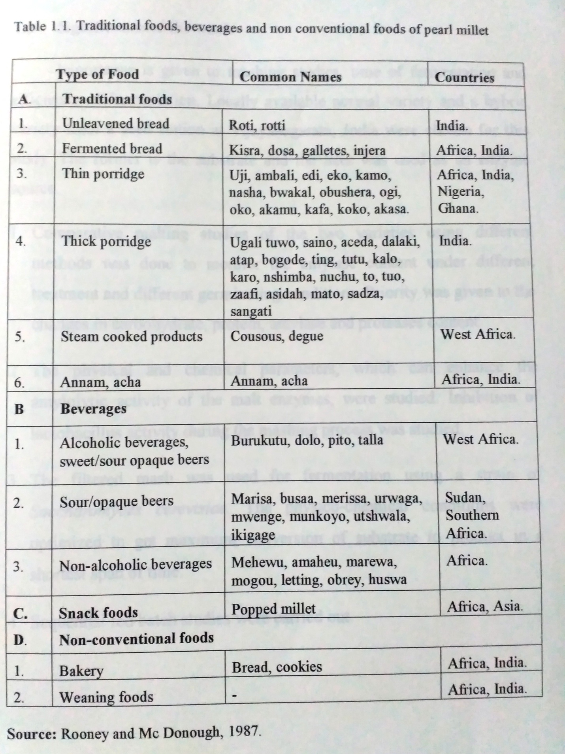

1.2 Significance of work
Importance is given to mashing studies, time of fermentation and efficiency of fermentation. Locally available normal variety and a hybrid variety from a seed station at Vijayanagaram , India were chosen for this study.
- Comparative malting studies of the two varieties using different methods was done to monitor the amylase content under different treatment and different germinating conditions. Priority was given to the changes in carbohydrate, protein, amylase and proteases content.
- The physical and chemical parameters, which can enhance the amylolytic activity of the malt enzymes were studied. Inhibition of lactobacillus activity during the mashing process was studied.
- The filtered mash was used for fermentation using a strain of Saccharomyces cerevisiae. The physic-chemical conditions were optimized to get maximum conversion of substrate to product in a shortest span of time.
- Sequential fed batch studies were carried out.

1.3 Objectives of the work

- Selection of a suitable seed germination procedure
- Selection of high amylase producing pearl millet variety
- Selection of different physic-chemical parameters, which enhance the amylase activity using synthetic starch
- Optimization of mashing conditions for maximum saccharification of pearl millet starch.
- Optimization of physic-chemical parameters in shake flask level
- Fed-batch fermentation studies to obtain higher ethanol yields.
- Bioreactor studies (STF) - Optimization of agitation.
- Comparison of ethanol production using shake flask and stirred tank fermentor.

